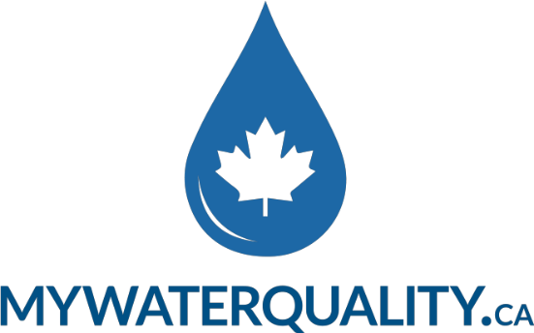

BIOGRAPHY

Tecia White, M.Sc., P. Geo
A practicing hydrogeologist for over 25 years with expertise in completing water quality and quantity analysis, Tecia White provides hands-on water quality testing and reporting services for homeowners related to their domestic water supplies.
She created My Water Quality in partnership with a laboratory to bring this new water supply sampling and reporting service to homeowners across Canada. The laboratory is a proud member of the Canadian Council of Independent Laboratories.
An honours graduate in Geology from McMaster University and with a Master of Science in Hydrogeology from University of Toronto, she has continued her education with advanced water quality studies through Waterloo University and Fractured Rock Educational Services.
She established Whitewater Hydrogeology Ltd. in 2009 to evaluate the influence of development on groundwater quality and quantity. and provides comprehensive regulatory and technical hydrogeological consulting services to municipalities, private industry and government agencies.
She has been a senior hydrogeologist for EarthFX Inc, and Azimuth Environmental Consulting Inc., and is a member of the Geological Association of Canada, International Association for Hydrogeologists, and is a registered member of the Association of Professional Geoscientists of Ontario.
.

